**PROJECT PROPOSAL**

**HUMAN RESOURCE MANAGEMENT WITH ATTENDANCE SYSTEM**

1. **SOLUTION DIRECTION**
   1. **PROBLEM DOMAIN**

An attendance management system is a cloud-based HR tech tool that enables organizations to automate their attendance management operations and keep track of employee working hours. It allows employees to mark their attendance through its website integrates with the biometric attendance system to sync attendance entries automatically. These attendance entries are centralized in a single system and can be accessed by HR teams from anywhere, at any time. The key aspects of the problem domain include:

* **Attendance Tracking and Accuracy**: Ensuring accurate recording of employee attendance, clock-ins, and clock-outs.
* **Integration with Payroll:** Seamlessly integrating attendance data with payroll systems.
* **Compliance and Legal Requirements**: Adhering to labor laws, regulations, and company policies related to attendance.
* **User-Friendly Interfaces:** Designing intuitive interfaces for employees to mark attendance and for HR teams to manage records.
* **Shift Scheduling and Management:** Efficiently managing employee shifts, rotations, and work schedules.
* **Biometric Integration and Security**: Integrating biometric systems (such as fingerprint or facial recognition) for attendance tracking.
* **Reporting and Analytics:** Generating insightful reports on attendance trends, absenteeism, and productivity.
* **Remote Work and Geolocation:** Managing attendance for remote workers and tracking geolocation-based clock-ins.
* **Employee Self-Service:** Empowering employees to view their attendance records, apply for leaves, and manage time off.

In addition to the core functionalities, the problem domain of HRM system also focuses on:

* **Security and Privacy**: Ensuring the protection of biometric data and preventing unauthorized access or misuse.
* **Device Maintenance and Calibration**: Regularly maintaining and calibrating biometric devices for accurate readings.
* **User Training and Adoption**: Educating employees effectively to maximize system utilization.
* **Handling Exceptions and Anomalies**: Addressing unexpected situations, system downtime, or disputes.
* **Data Retention and Archiving**: Properly storing and managing historical attendance records.
* **Scalability for Large Organizations**: Designing the system to accommodate workforce growth.
* **Real-Time Alerts and Notifications**: Promptly notifying HR of unusual attendance patterns.
  1. **SOLUTION DOMAIN**

**1.2.1 The Discussion of Alternative Solutions**

In this section, we will explore different solution directions such as web-based applications, desktop-based applications, mobile applications or hybrid solution(web + mobile). Considering the unique requirements of HRM and attendance management, we decided to develop a web-based application, other alternatives were discarded due to the following limitations:

|  |  |
| --- | --- |
| **Alternative** | **Discard reasons** |
| Desktop-based application |  ✗  Tie users to specific workstations, limiting their ability to work remotely or access HRM features from different devices.   ✗ Require manual updates on each machine where they are installed.   ✗ Attendance systems can be susceptible to time fraud, such as “buddy punching,” where employees clock in for absent colleagues.   ✗ Rely on local hardware and infrastructure, making them less flexible for distributed teams or remote work.   ✗ May lack the robust security features found in modern web or mobile apps.   ✗ Ensuring data security and privacy on individual workstations can be challenging. |
| Mobile application |  ✗ Mobile apps are vulnerable to malware, data breaches, and unauthorized access.   ✗ Mobile apps may not work on all devices (e.g., older phones, different operating systems).   ✗ Approval process and restrictions can be time-consuming.   ✗ Updates and compatibility issues across various devices. |
| Hybrid solution |  ✗ Integrating web and mobile components can be challenging.   ✗ Requires managing both web and mobile aspects.   ✗ Hybrid solutions may not perform as well as native apps. |

The Web-Based Application offers the best balance of flexibility, scalability, ease of maintenance, and security. It supports remote work, aligns with modern work practices, and has existing successful competitors. While other solutions have merits, the web-based approach provides the most comprehensive benefits for HRM and attendance management.

Besides, we will deploy the web-based approach on **AWS** instead of other hosting options, such as a dedicated server, or on-premises as it is requested by client, and AWS is also more flexible than other ways in many aspects:

|  |  |  |  |
| --- | --- | --- | --- |
| **Criteria** | **AWS** | **Dedicated server** | **On-premises** |
| **Cost** | Variable cost: Pay-as-you-go pricing based on usage. Initial setup costs may be lower. | Fixed cost: Requires purchasing or leasing dedicated hardware. Higher initial investment. | Fixed cost: Requires purchasing and maintaining hardware infrastructure. |
| **Scalability** | Highly scalable: Easily adjust resources based on demand. | Limited scalability: Hardware capacity is fixed. Scaling requires additional servers. | Limited scalability: Hardware capacity is fixed. Scaling requires new hardware. |
| **Maintenance** | Managed service: AWS handles maintenance, updates, and security. | Self-managed: You’re responsible for maintenance, updates, and security. | Self-managed: You’re responsible for all aspects of maintenance. |
| **Reliability** | Highly reliable: AWS data centers are distributed globally. | Depends on provider: Varies based on service level agreements. | Depends on organization: In-house infrastructure reliability. |
| **Flexibility** | Highly reliable: AWS data centers are distributed globally. | Depends on provider: Varies based on service level agreements. | Depends on organization: In-house infrastructure reliability. |
| **Deployment Time** | Quick deployment: Provision resources within minutes. | Moderate deployment time: Requires setting up and configuring hardware. | Longer deployment time: Procurement, setup, and configuration. |
| **Location Independence** | Global availability: Accessible from anywhere with an internet connection. | Dependent on server location: Limited to physical server location. | Dependent on office premises: Limited to local network. |
| **Security** | AWS provides security features: Encryption, firewalls, IAM, etc. | Depends on provider: Security measures vary. | Depends on organization: In-house security policies and practices. |

1.2.2. The KoST Analysis of My Knowledge

* **Knowledge *(what you know)***

Required knowledge

* **Web-based application**: Proficiency in HTML, CSS, and JavaScript for creating user interfaces, knowledge of server-side programming languages such as Python, Java or Node.js
* **Desktop-based application**: Proficiency in C++, Java, and C#.
* **Hosting server**: Expertise in server management, networking, databases, and understanding of hosting services.
* **Biometric Integration**: Learn about integrating biometric devices (e.g., fingerprint scanners) with your application. Understand how to capture and process biometric data securely.
* **HR Management Basics**: Possess basic knowledge of HR management through engagement in volunteer operations involving personnel allocation and administration.

My team’s Knowledge

* All of our team have member had enrolled in two web development courses; hence, they can understand the basic understanding of HTML, CSS, JavaScript and PHP.
* One of our team members had enrolled in IoT programing and can develop IoT related project.
* Two of us was enrolled in the AWS architecture designing course. Which prompts understanding of networking, DBMS and hosting services.
* One team member is in the HR sector of a club. Which helps with our domain problem.
* **Skills *(your experience)***

Required skills

Technical Skills:

* Understanding of responsive design principles.
* Ability to develop APIs for communication between front-end and back-end.
* Familiarity with database management (e.g., MySQL, PostgreSQL, or MongoDB).
* Understanding of server inspection and deployment into production environments.
* Knowledge of how to acquire necessary infrastructure (e.g., cloud hosting, virtual servers).
* Experience in creating intuitive and user-friendly interfaces for HRM applications.

Domain knowledge:

* Understanding of HR functions related to attendance tracking, leave management, and payroll.
* Understanding of the benefits and challenges of using biometrics for attendance management.
* Familiarity with HRM processes specific to attendance, employee records, and time tracking.
* Knowledge of how biometric attendance fits into the overall HR ecosystem.

My team’s skills

* All of us have created and hosted a few websites as our side and university projects.
* One of us had UX/UI designing experiences and is proficient in Adobe XD, Figma.
* Another one had created and managed database using SQL developer by Oracle.
* The IoT proficient member had built various IoT machines that function well.
* We have had experience observing the HRM pipeline and process of a club.
* **Technology *(existing solution)***

Various contemporary technologies and solutions can be leveraged to develop web-based HRM systems. Key among these are:

* **Proprietary HRM Software**: Esteemed companies such as SAP (SuccessFactors), Oracle (Oracle HCM Cloud), and Workday present comprehensive HRM suites encompassing diverse HR functions. These solutions typically include modules for core HR, talent management, workforce planning, payroll, benefits administration, and analytics.
* **Cloud-based HRM Platforms**: Scalable and adaptable solutions for managing HR processes are offered by cloud-based HRM platforms like BambooHR, Namely, Zenefits, and Gusto. These platforms commonly feature employee self-service portals, tools for onboarding and offboarding, performance management, time and attendance tracking, as well as compliance management.
* **Open-source HRM Solutions**: Flexibility and customization are core benefits of open-source HRM solutions, making them ideal for constructing web-based HRM applications. Well-regarded open-source HRM frameworks and platforms include OrangeHRM, Sentrifugo, IceHrm, and Odoo HR. These solutions provide modules for managing employee information, leave management, attendance tracking, and more.
* **HRM Modules within ERP Systems**: Enterprise Resource Planning (ERP) systems like Microsoft Dynamics 365 and SAP ERP often include HRM modules alongside other business functions such as finance, supply chain, and manufacturing. These integrated solutions provide a unified platform for managing HR processes within the broader context of organizational operations.

**Rationale**

After a gap analysis using the KsoT framework and a comparison analysis of several solutions, the following factors suggest that creating a web application is the best course of action for this project:

* Web-based apps can be easily integrated and blended in with the existing system because they are easily accessible from a variety of devices and have an intuitive interface.
* The platform can grow to meet the needs of its users thanks to the scalability features offered by Firebase and Google cloud.
* Our team is fairly competent of producing a project this scale.

**1.2.3. Final Solution**

* The HRM application will be developed as a web-based application with a front-end built with Vue JS and a back-end utilizing a combination of Node Js and Express Js.
* The HRM Application will be developed using Nginx Web Servers, with Firebase hosting the back end. This combination will ensure the necessary scalability and reliability for this project.
* Google Spreadsheet on Google Cloud will be utilized to store user data due to its exceptional capacity to manage vast amounts of data. Additionally, Google's security and compliance measures are of the highest caliber, helping to safeguard critical user information.

1. **ARCHITECTURE DESIGN**
   1. **3-TIER ARCHITECTURE**

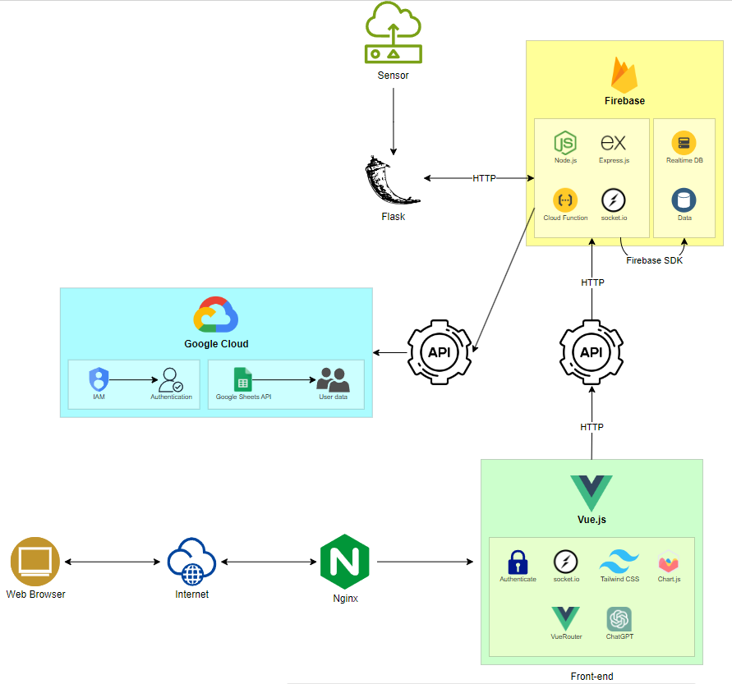

*Figure A: 3-tier Website Application Design*

**TIER 1**: **PRESENTATION**

* Cloudflare: Provides secure DNS and website optimization services.
* Vue.js: A progressive JavaScript framework for building user interfaces.
* Vue Router: For client-side routing within the Vue.js application.
* Vuex: State management library for Vue.js applications.
* Vue Auth: Authentication library for handling user authentication.
* Socket.io: Enables real-time client-server communication for notifications.
* Tailwind CSS / Bootstrap: CSS frameworks for styling user interfaces.
* Chart.js: JavaScript library for creating charts and graphs.

**TIER 2: APPLICATION**

Application 1:

* Flask: A micro web framework written in Python.
* Biometric Attendance: Module for retrieving employee attendance using biometric data.
* Flask API: Creates APIs to facilitate communication between servers.

Application 2:

* Node.js: A JavaScript runtime environment for executing server-side code.
* Express.js: A web application framework for Node.js.
* Socket.io: Enables real-time server-client communication for notifications.
* RESTful API: Provides endpoints for interacting with the application.
* Real-Time Database (RTDB): Firebase's NoSQL database for real-time data storage, suitable for IoT data.
* Google Spreadsheet: Integration with Google Sheets for data storage.
* IAM Service: Registers and manages access permissions for connecting to Google Sheets.

**TIER 3: DATABASE**

* Google Spreadsheet: Google Sheets used as a database for storing structured data.
* Real-Time Database (RTDB): Firebase's NoSQL database for real-time data storage.

**2.2 UML DESIGN**

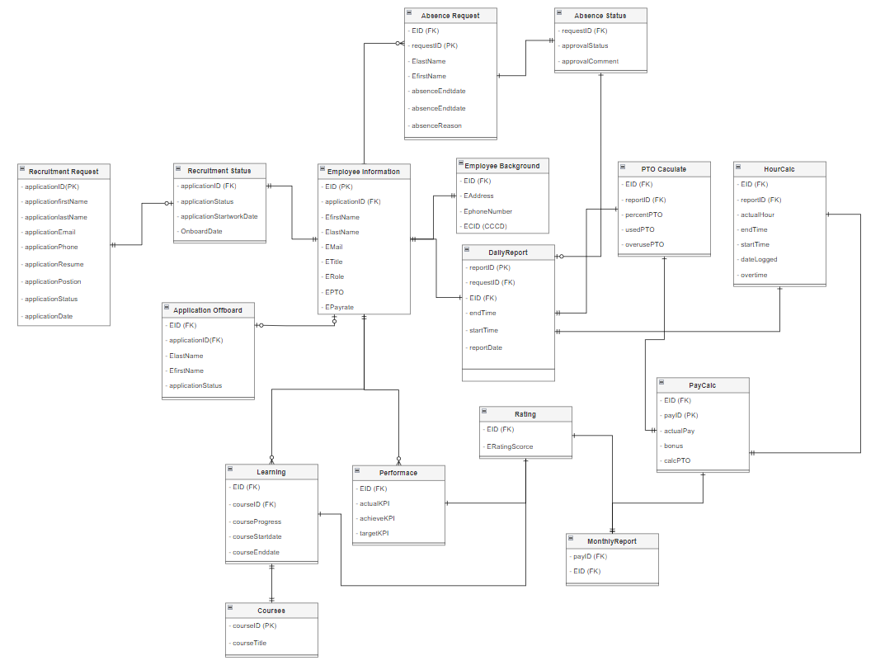

*Figure B: UML Design*